# Lab-7 WAP to study Using recursion in prolog.

Procedure:-

Write predicate fact(n) ,which finds and display factorial of a given number .

Example:- Output:- Goal :- fact(5) 5 != 5*4*3*2*1= 120 .

**CODE:**

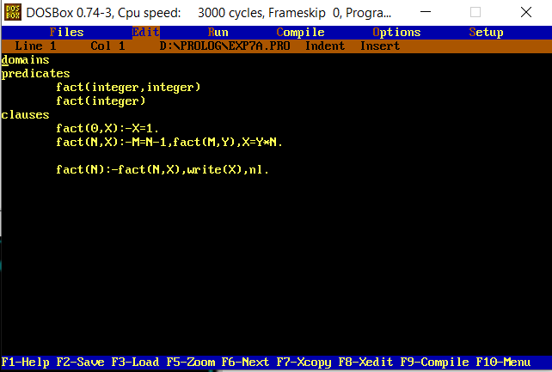

**domains**

**predicates**

**fact(integer,integer)**

**fact(integer)**

**clauses**

**fact(0,X):-X=1.**

**fact(N,X):-M=N-1,fact(M,Y),X=Y*N.**

**fact(N):-fact(N,X),write(X),nl.**

**OUTPUTS:**

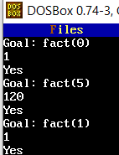

Write predicate fibbonacci (n) ,which finds the series for first “n” values .

Example:-

Output:- Total number of numbers needed in output? 6

Fibonacci series of first “6‟

numbers:- 1,1,2,3,5,8

**CODE:**

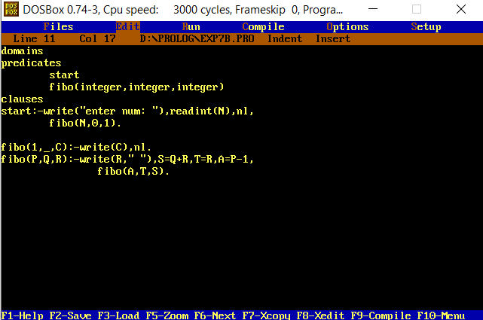

**domains**

**predicates**

**start**

**fibo(integer,integer,integer)**

**clauses**

**start:-write("enter num: "),readint(N),nl,**

**fibo(N,0,1).**

**fibo(1,_,C):-write(C),nl.**

**fibo(P,Q,R):-write(R," "),S=Q+R,T=R,A=P-1,**

**fibo(A,T,S).**

**OUTPUTS:**

